

Note:

I made Two Web applications on same website One is Labour Hire Management System and for Second application I added Ecommerce feature to it.

Below mentioned are based on my first Application Which has Product/Service Management system features as well as Customer Service Management feature

Labour Hire Application

Labour Hire Application is a web application where people can hire any type of labours like Electrician, plumber, carpenter and gardener etc. This application allows the users to select their appropriate location and type of labour they need. According to search made by the user appropriate labour details will be displayed and the user can book them according to their requirements. And with added Functionality of searching for repair parts during the labour booking is implemented

THIS IS THE HOME PAGE



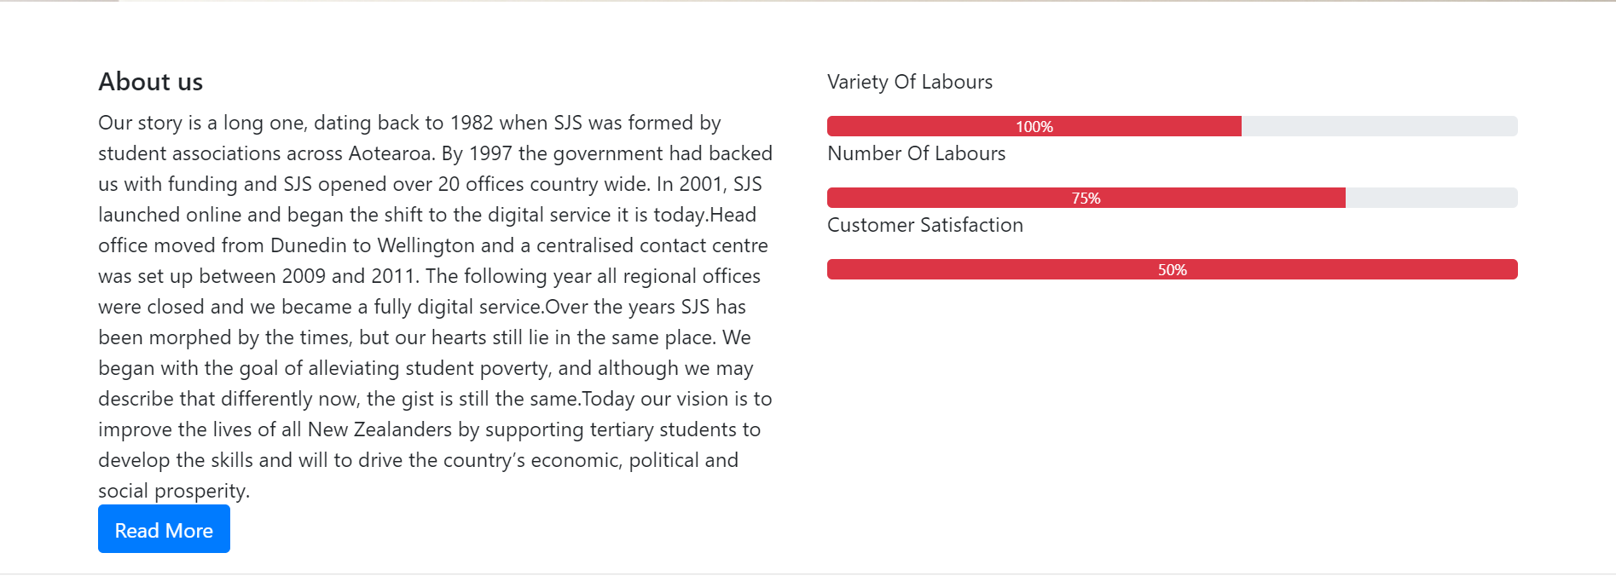

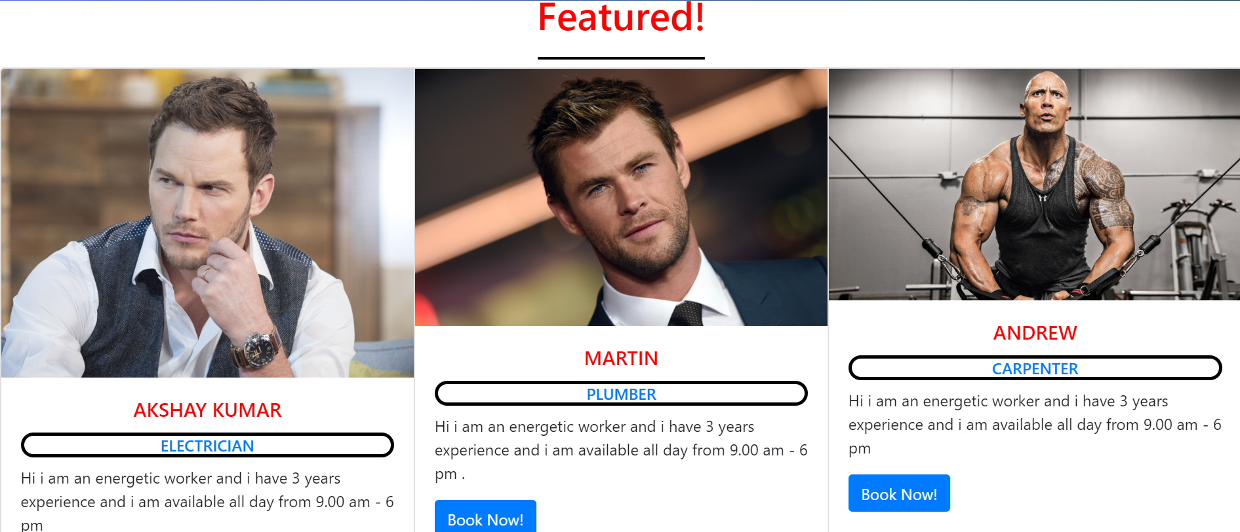

The User Have To Choose Type of Labour They want and the Location from the dropdown boxList

And Click GO

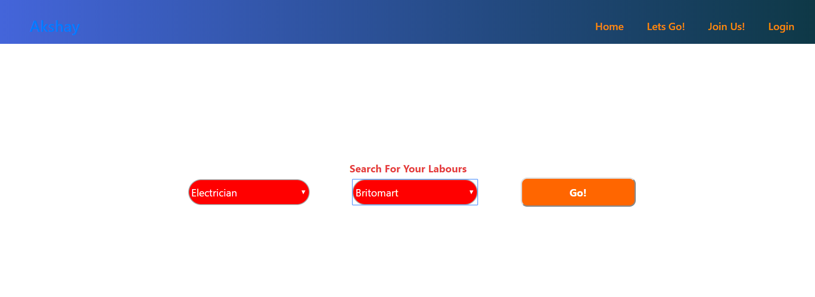

This is the grid Boxes that are generated from the Sql Database according to the selection made by the user in the Previous page

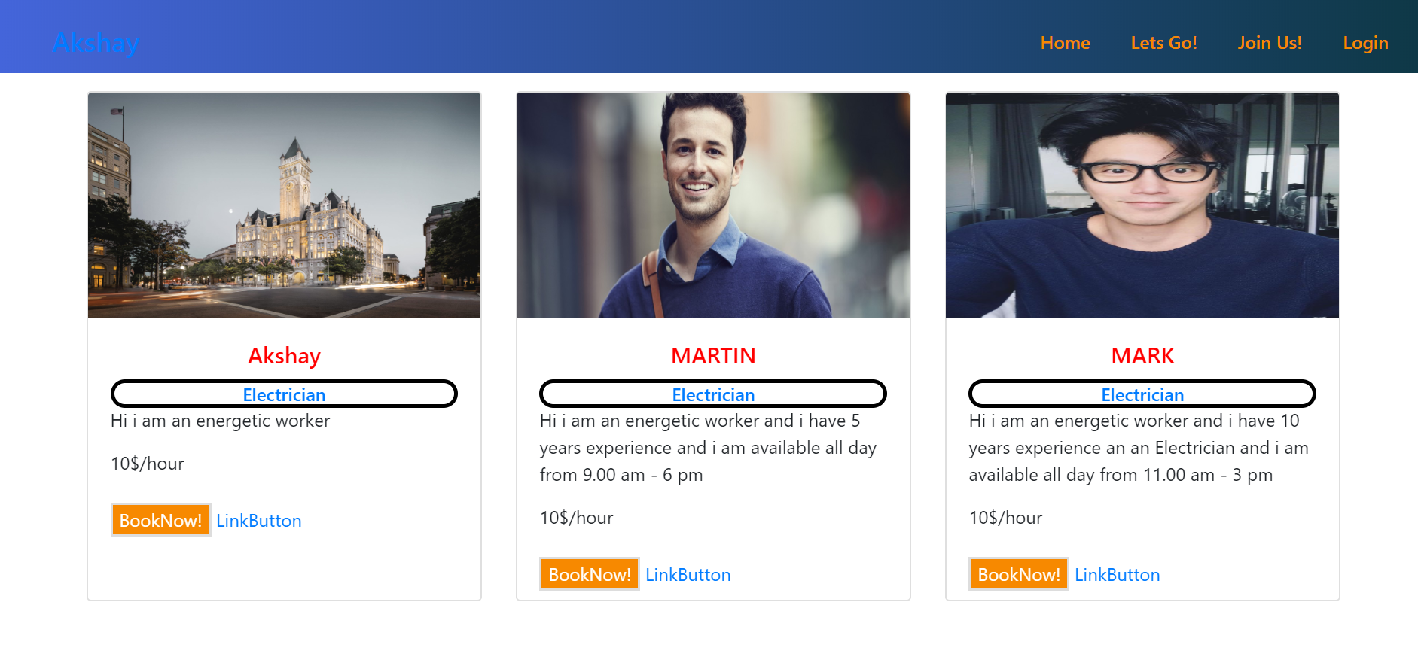

When User Clicks the BookNow The CartPage is Displayed which has Details of the Labour they Booked

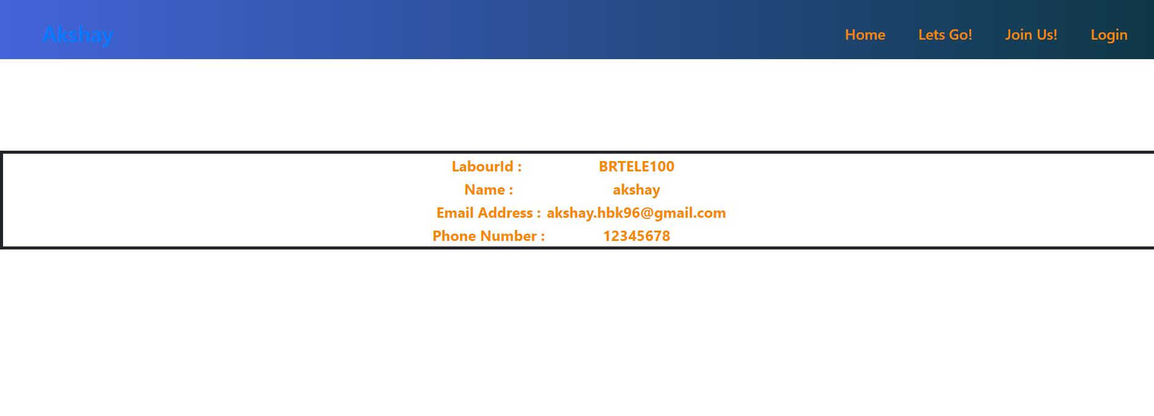

This is the Login Page created for Clients Who have already Registered with Us

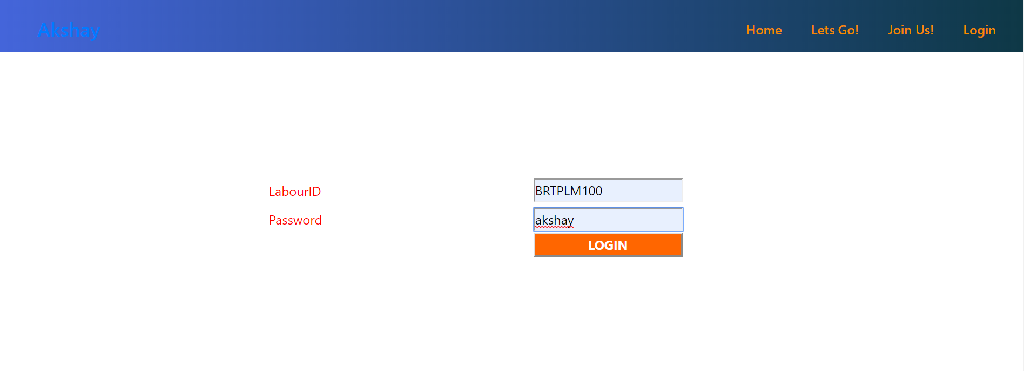

After Client Login is done He is allowed to Update the Details Of his and Click Update . All the changes will reflect on GridView also

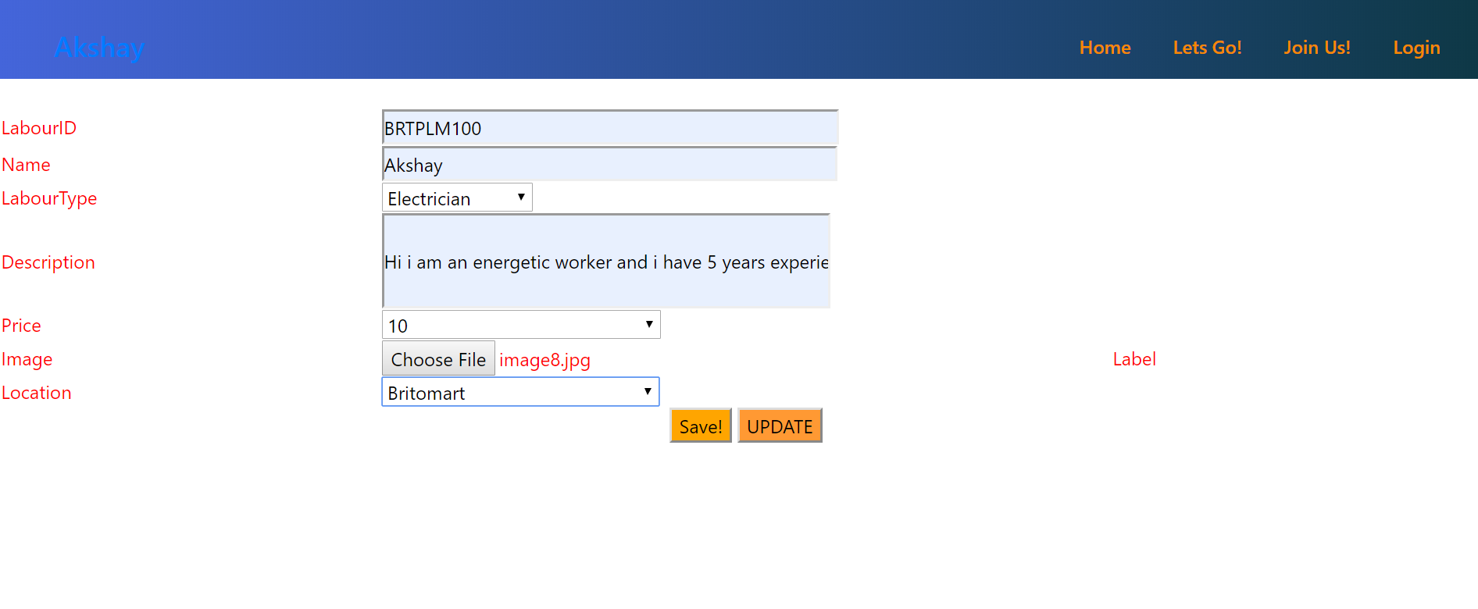

This Page is for New Clients Who wants to Register with us . This page contains LabourId,Name,Email, ContactNumber and Password

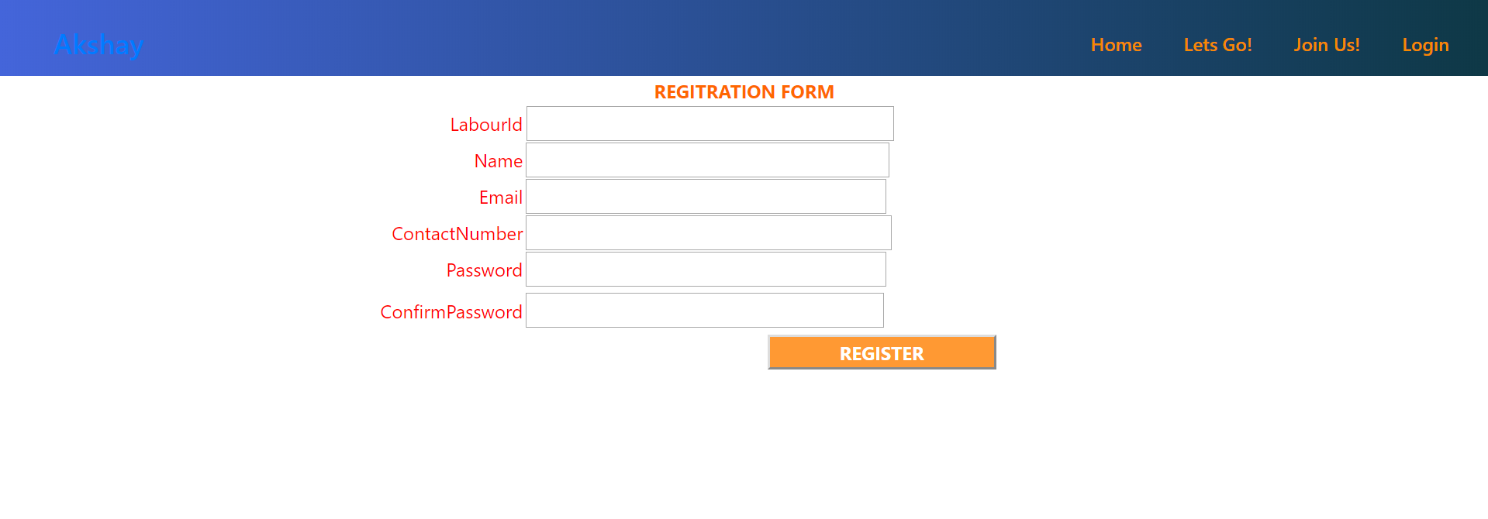

This is Login Page for the Admin Who has Access to delete a client or add or Update a client Details

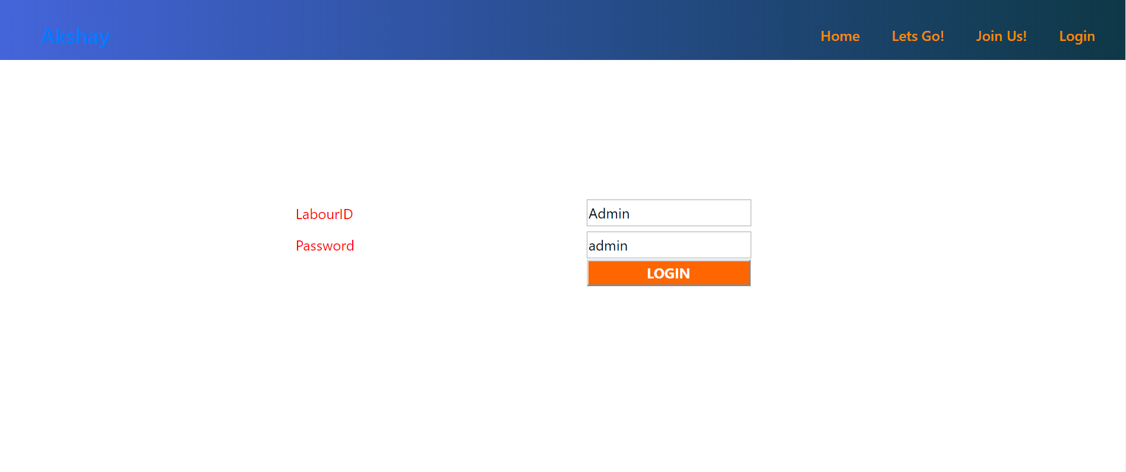

This is the Admin view and he can choose any one of the Labourid from the Dropdown boxes and click Delete to remove the Client and Similarly we can add or update the client details

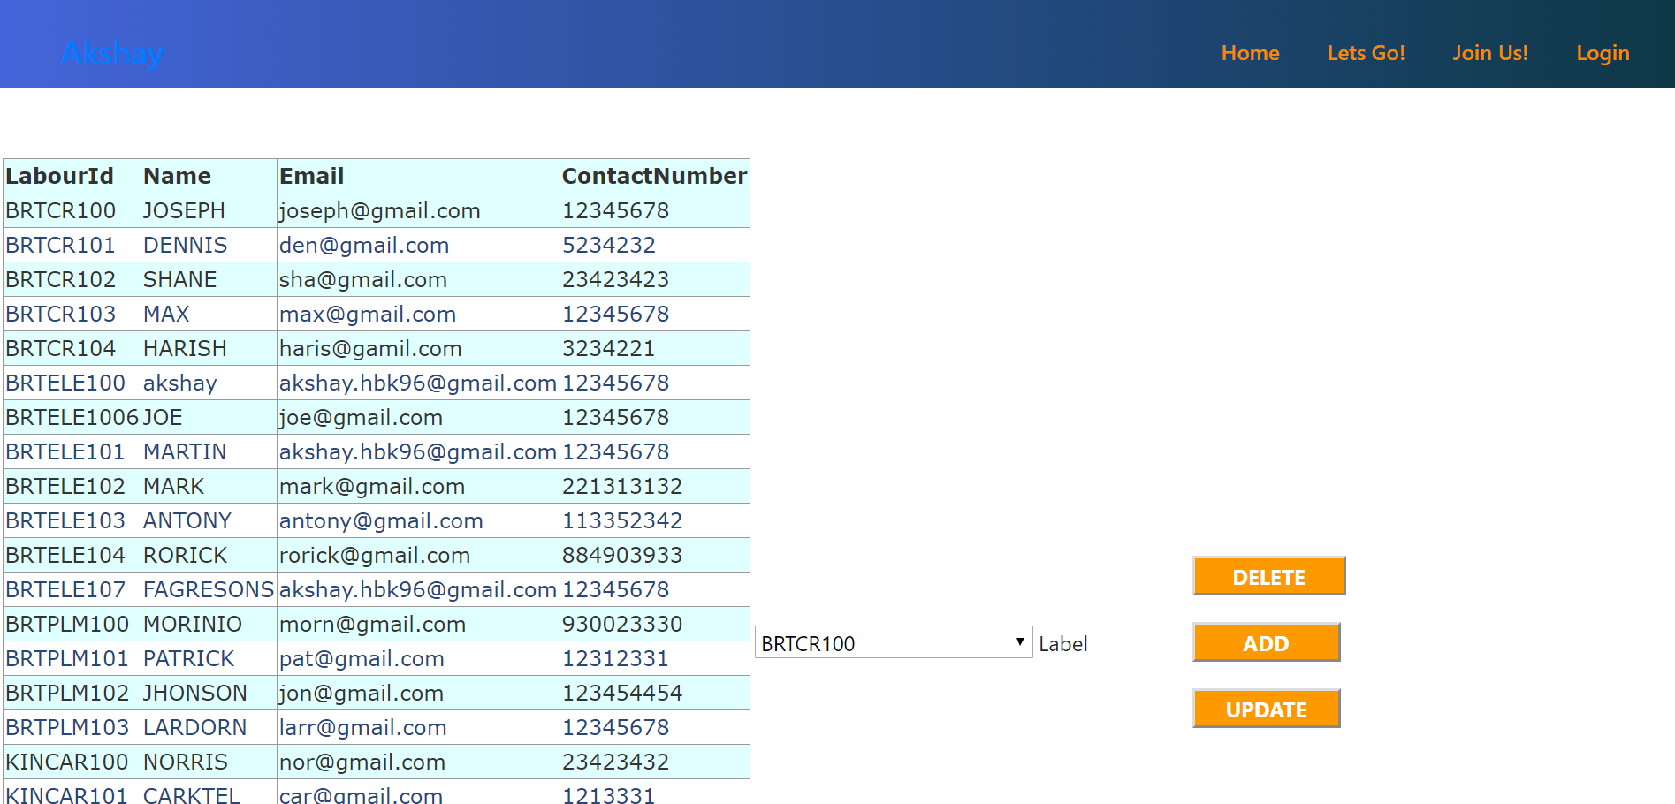

DML:

create table Register(LabourId varchar(10) not null,

Name varchar(30) not null,

Email varchar(30) not null,

ContactNumber int not null,

Password varchar(30) not null,

ConfirmPassword varchar(30) not null

constraint RegisterPK primary key(LabourId));

Create Table Britomart_Electrician(LabourId varchar(10) not null,

Name varchar(25) not null,

LabourType varchar(15) not null,

Description varchar(max) not null,

Price int not null,

Image varchar(max) not null

Constraint BritomartPK primary key(LabourId),

constraint BritomartFK foreign key(LabourId)

references Register (LabourId)

on update cascade

on delete cascade);

Create Table Britomart_Plumber(LabourId varchar(10) not null,

Name varchar(25) not null,

LabourType varchar(15) not null,

Description varchar(max) not null,

Price int not null,

Image varchar(max) not null

Constraint BritomartplumPK primary key(LabourId)

constraint BritomartplumFK foreign key(LabourId)

references Register (LabourId)

on update cascade

on delete cascade);

Create Table Britomart_Carpenter(LabourId varchar(10) not null,

Name varchar(25) not null,

LabourType varchar(15) not null,

Description varchar(max) not null,

Price int not null,

Image varchar(max) not null

Constraint BritomartcarPK primary key(LabourId)

constraint BritomartcarFK foreign key(LabourId)

references Register (LabourId)

on update cascade

on delete cascade);

Create Table Kingsland_Electrician(LabourId varchar(10) not null,

Name varchar(25) not null,

LabourType varchar(15) not null,

Description varchar(max) not null,

Price int not null,

Image varchar(max) not null

Constraint KingslandPK primary key(LabourId)

constraint KingsFK foreign key(LabourId)

references Register (LabourId)

on update cascade

on delete cascade);

Create Table Kingsland_Plumber(LabourId varchar(10) not null,

Name varchar(25) not null,

LabourType varchar(15) not null,

Description varchar(max) not null,

Price int not null,

Image varchar(max) not null

Constraint KingslandplumPK primary key(LabourId)

constraint KingsplumFK foreign key(LabourId)

references Register (LabourId)

on update cascade

on delete cascade);

Create Table Kingsland_Carpenter(LabourId varchar(10) not null,

Name varchar(25) not null,

LabourType varchar(15) not null,

Description varchar(max) not null,

Price int not null,

Image varchar(max) not null

Constraint KingslandcarPK primary key(LabourId)

constraint KingscarFK foreign key(LabourId)

references Register (LabourId)

on update cascade

on delete cascade);

Create table Admin(LabourId varchar(10) not null,

Password varchar(10) not null);

DDL:

select * from Register

insert into Register values('BRTCR100','JOSEPH','joseph@gmail.com','12345678','akshay','akshay'),

('BRTCR101','DENNIS','den@gmail.com','12345678','akshay','akshay'),

('BRTCR102','SHANE','sha@gmail.com','12345678','akshay','akshay'),

('BRTCR103','MAX','max@gmail.com','12345678','akshay','akshay'),

('BRTCR104','HARISH','haris@gamil.com','12345678','akshay','akshay'),

('BRTELE101','JOSMARTINEPH','akshay.hbk96@gmail.com','12345678','akshay','akshay'),

('BRTELE102','MARK','mark@gmail.com','12345678','akshay','akshay'),

('BRTELE103','ANTONY','antony@gmail.com','12345678','akshay','akshay'),

('BRTELE104','RORICK','rorick@gmail.com','12345678','akshay','akshay'),

('BRTELE107','FAGRESONS','rorick@gmail.com','12345678','akshay','akshay'),

('BRTPLM100','MORINIO','morn@gmail.com','12345678','akshay','akshay'),

('BRTPLM101','PATRICK','pat@gmail.com','12345678','akshay','akshay'),

('BRTPLM102','JHONSON','jon@gmail.com','12345678','akshay','akshay'),

('BRTPLM103','LARDORN','larr@gmail.com','12345678','akshay','akshay'),

('KINCAR100','NORRIS','nor@gmail.com','12345678','akshay','akshay'),

('KINCAR101','CARKTEL','car@gmail.com','12345678','akshay','akshay'),

('KINCAR102','QUANTES','Quan@gmail.com','12345678','akshay','akshay'),

('KINELE100','ROHIT','rohith@gmail.com','12345678','akshay','akshay'),

('KINELE101','SHEKAR','she@gmail.com','12345678','akshay','akshay'),

('KINELE102','DHONI','dhoni@gmail.com','12345678','akshay','akshay'),

('KINELE103','GAYLE','gle@gmail.com','12345678','akshay','akshay'),

('KINPLM100','JACKSON','jack@gmail.com','12345678','akshay','akshay'),

('KINPLM101','HENDRY','hen@gmail.com','12345678','akshay','akshay'),

('KINPLM102','FAGRESON','fag@gmail.com','12345678','akshay','akshay'),

('KINPLM103','akshay','akshay.hbk96@gmail.com','12345678','akshay','akshay');

Select * from Britomart_Electrician

insert into Britomart_Electrician values('BRTELE100','Akshay','Electrician','Hi i am an energetic worker','10','images/hotels.jpg'),

('BRTELE101','MARTIN','Electrician','Hi i am an energetic worker and i have 5 years experience and i am available all day from 9.00 am - 6 pm ','10','images/image2.jpg'),

('BRTELE102','MARK','Electrician','Hi i am an energetic worker and i have 5 years experience and i am available all day from 9.00 am - 6 pm ','10','images/image3.jpg'),

('BRTELE103','ANTONY','Electrician','Hi i am an energetic worker and i have 5 years experience and i am available all day from 9.00 am - 6 pm ','10','images/image4.jpg'),

('BRTELE104','RORICK','Electrician','Hi i am an energetic worker and i have 5 years experience and i am available all day from 9.00 am - 6 pm ','10','images/image5.jpg');

Select * from Britomart_Carpenter

insert into Britomart_Carpenter values('BRTCR100','JOSEPH','Carpenter','Hi i am an energetic worker','10','images/image9.jpg'),

('BRTCR101','DENNIS','Carpenter','Hi i am an energetic worker and i have 5 years experience and i am available all day from 9.00 am - 6 pm ','10','images/image10.jpg'),

('BRTCR102','SHANE','Carpenter','Hi i am an energetic worker and i have 5 years experience and i am available all day from 9.00 am - 6 pm ','10','images/image1.jpg'),

('BRTCR103','MAX','Carpenter','Hi i am an energetic worker and i have 5 years experience and i am available all day from 9.00 am - 6 pm ','10','images/image6.jpg'),

('BRTCR104','HARISH','Carpenter','Hi i am an energetic worker and i have 5 years experience and i am available all day from 9.00 am - 6 pm ','10','images/image4.jpg');

select * from Britomart_Plumber

insert into Britomart_Plumber values('BRTPLM100','MORINIO','Plumber','Hi i am an energetic worker','10','images/image6.jpg'),

('BRTPLM101','PATRICK','Plumber','Hi i am an energetic worker and i have 5 years experience and i am available all day from 9.00 am - 6 pm ','10','images/image9.jpg'),

('BRTPLM102','JHONSON','Plumber','Hi i am an energetic worker and i have 5 years experience and i am available all day from 9.00 am - 6 pm ','10','images/image7.jpg'),

('BRTPLM103','LARDORN','Plumber','Hi i am an energetic worker and i have 5 years experience and i am available all day from 9.00 am - 6 pm ','10','images/image8.jpg');

Select * from Kingsland_Electrician

insert into Kingsland_Electrician values ('KINELE100','ROHIT','Electrician','Hi i am an energetic worker','20','images/image11.jpg'),

('KINELE101','SHEKAR','Electrician','Hi i am an energetic worker and i have 5 years experience and i am available all day from 9.00 am - 6 pm ','30','images/image12.jpg'),

('KINELE102','DHONI','Electrician','Hi i am an energetic worker and i have 5 years experience and i am available all day from 9.00 am - 6 pm ','20','images/image14.jpg'),

('KINELE103','GAYLE','Electrician','Hi i am an energetic worker and i have 5 years experience and i am available all day from 9.00 am - 6 pm ','20','images/image17.jpg');

select * from Kingsland_Plumber

insert into Kingsland_Plumber values ('KINPLM100','JACKSON','Plumber','Hi i am an energetic worker','20','images/image20.jpg'),

('KINPLM101','HENDRY','Plumber','Hi i am an energetic worker and i have 5 years experience and i am available all day from 9.00 am - 6 pm ','30','images/image8.jpg'),

('KINPLM102','FAGRESON','Plumber','Hi i am an energetic worker and i have 5 years experience and i am available all day from 9.00 am - 6 pm ','20','images/image17.jpg'),

('KINPLM103','Akshay','Plumber','Hi i am an energetic worker and i have 5 years experience and i am available all day from 9.00 am - 6 pm ','20','images/image15.jpg');

select * from Kingsland_Carpenter

insert into Kingsland_Carpenter values ('KINCAR100','NORRIS','Plumber','Hi i am an energetic worker','20','images/image20.jpg'),

('KINCAR101','CARKTEL','Plumber','Hi i am an energetic worker and i have 5 years experience and i am available all day from 9.00 am - 6 pm ','30','images/image1.jpg'),

('KINCAR102','QUANTES','Plumber','Hi i am an energetic worker and i have 5 years experience and i am available all day from 9.00 am - 6 pm ','20','images/image5.jpg');

**Advancements and New features Made on Assignment2**

**Products/services Management System**

Search can be done by category in drop down list or search box

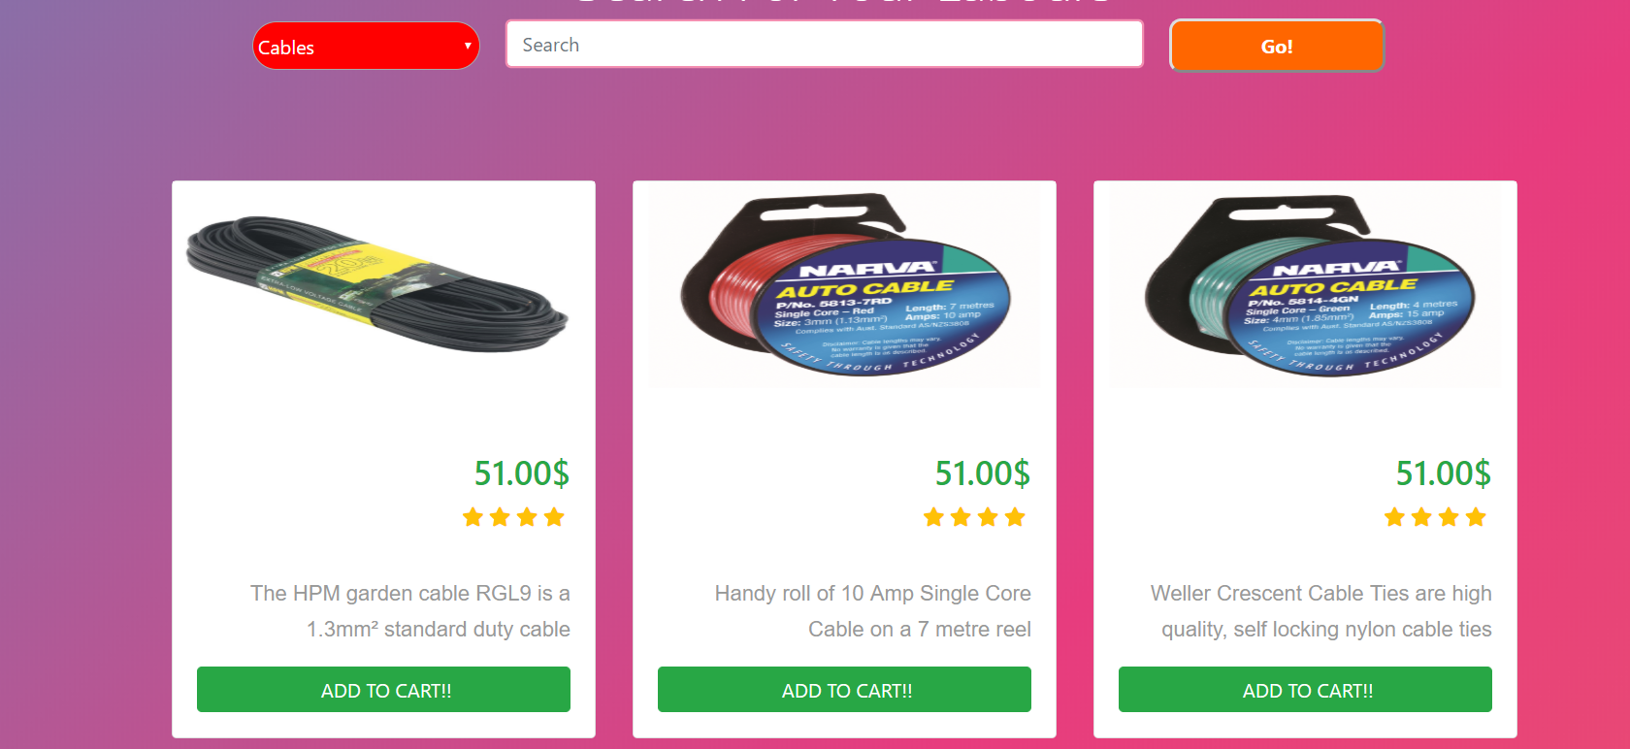

Products can Be added Or Updated

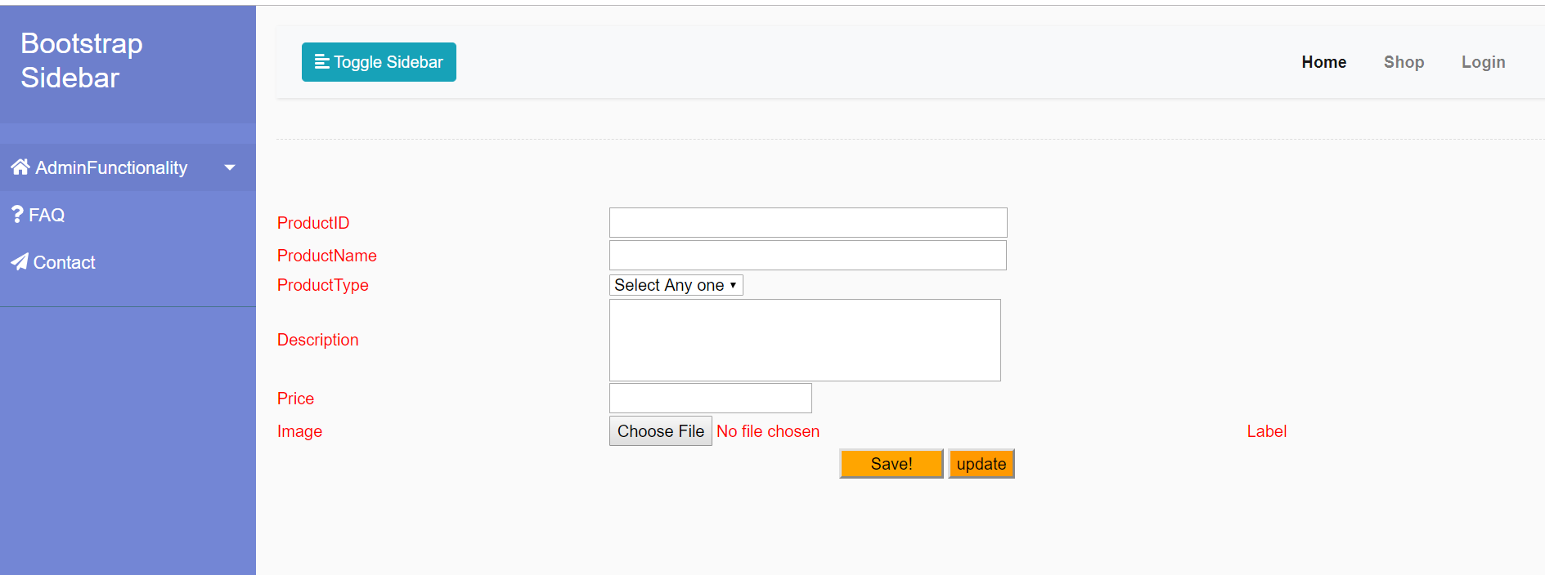

Admin Can Promote the Client to get displayed in the Home Page



CART PAGE

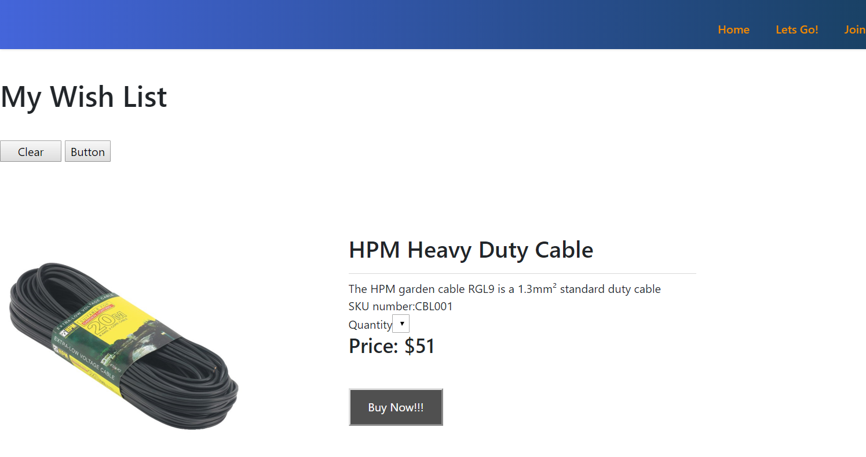Using Hashing algorith for storing user Password with salt



Login Page

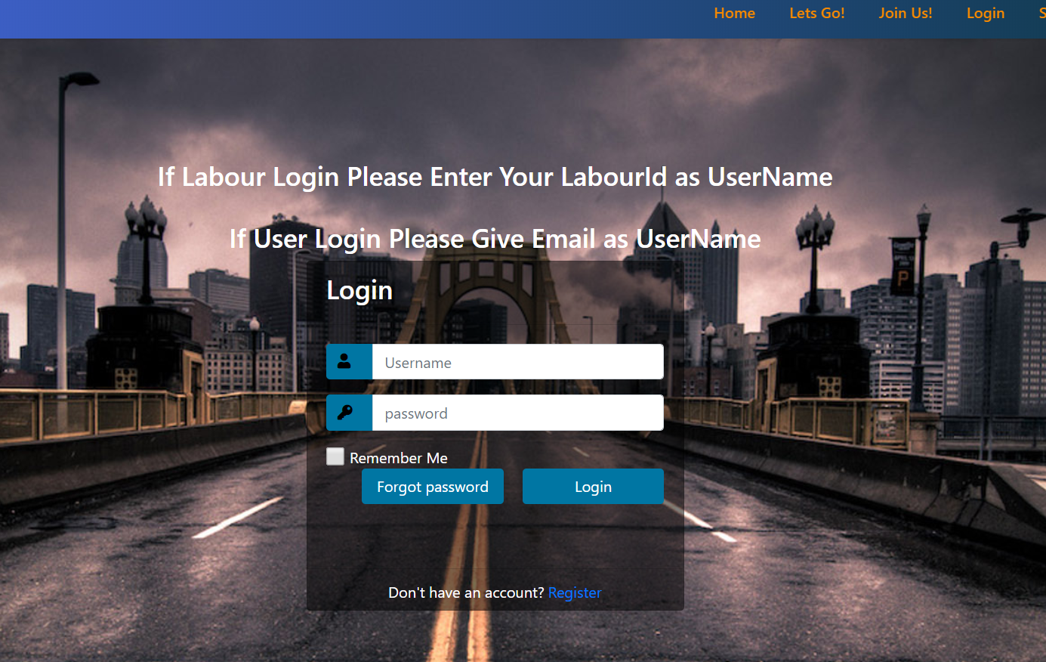

Register Page

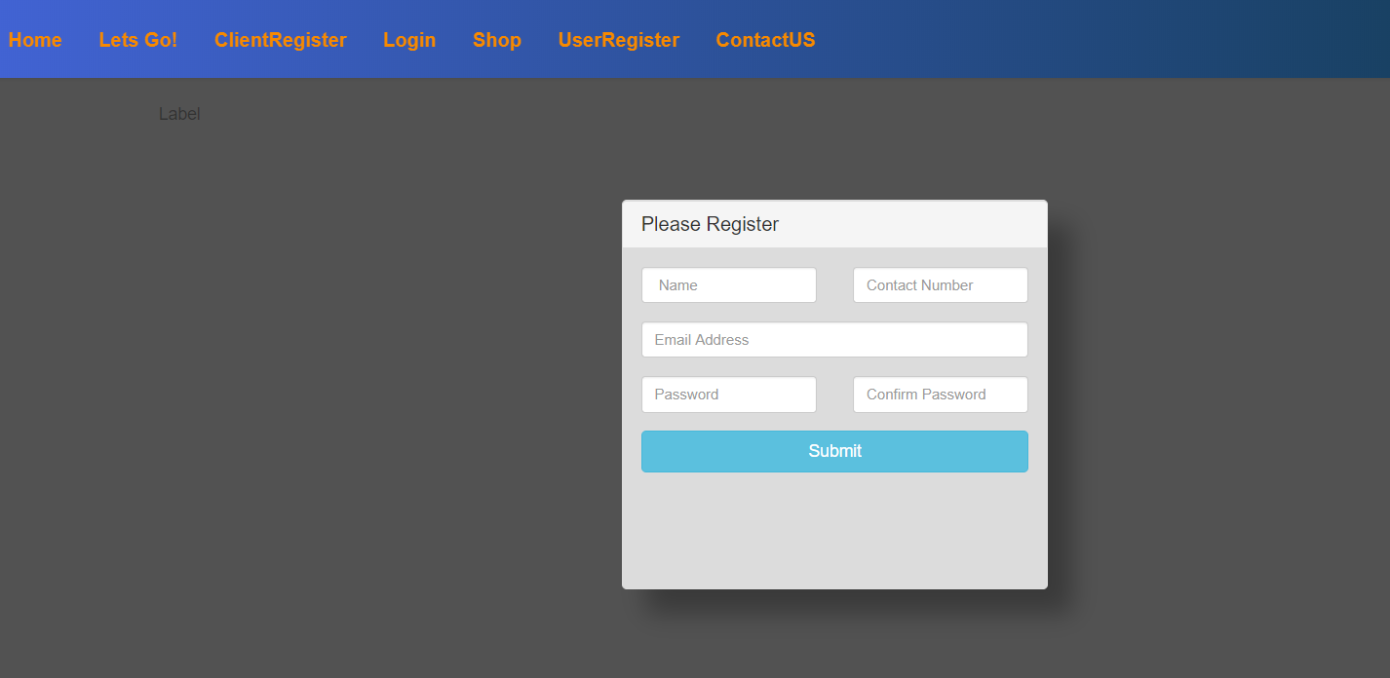

Forgot Password

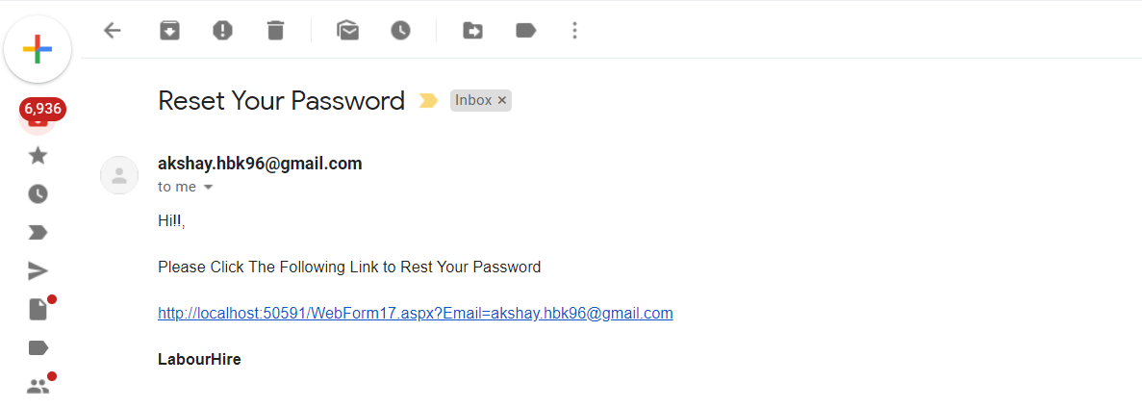

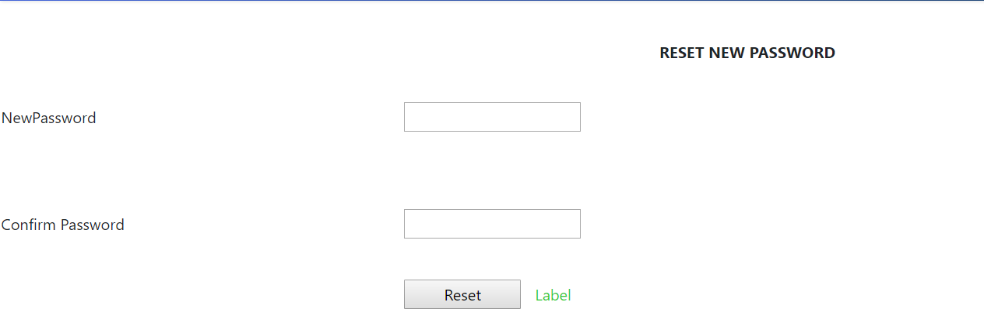

Contact Us

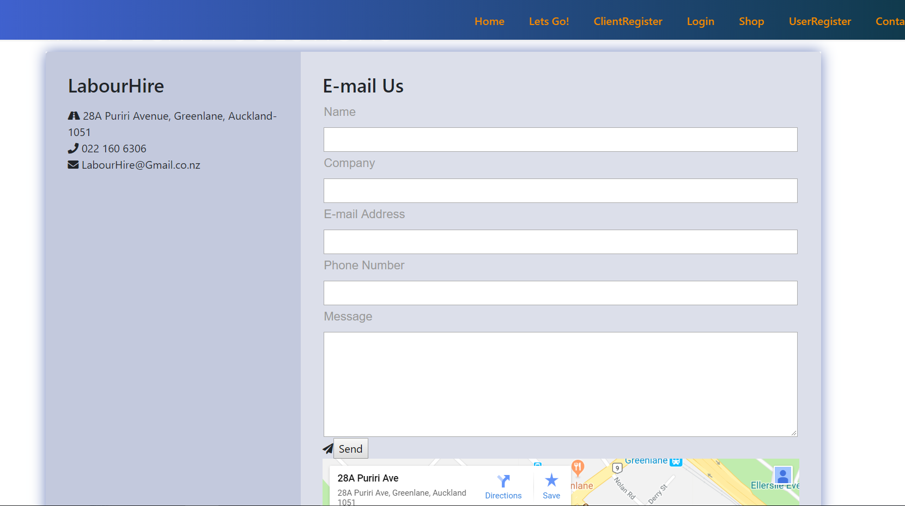

Error Pages

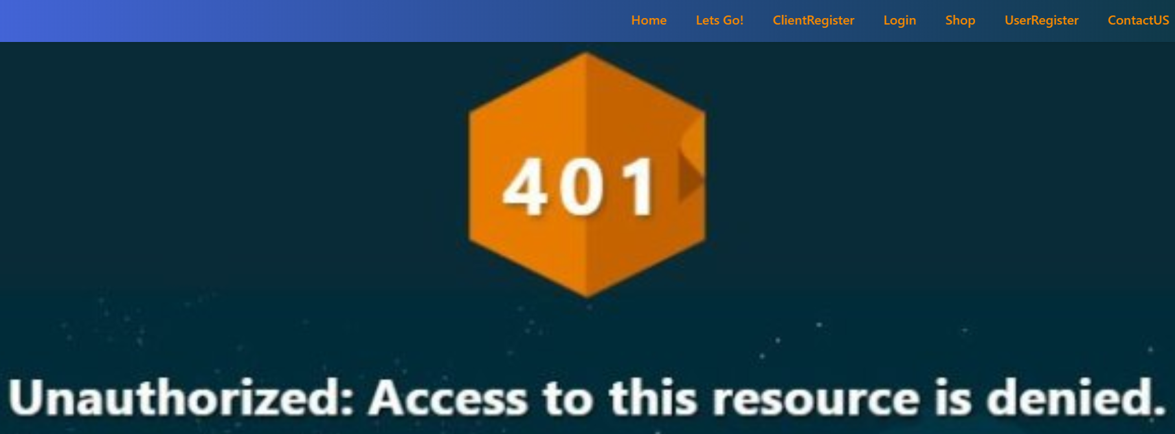





ADMIN Dashboard

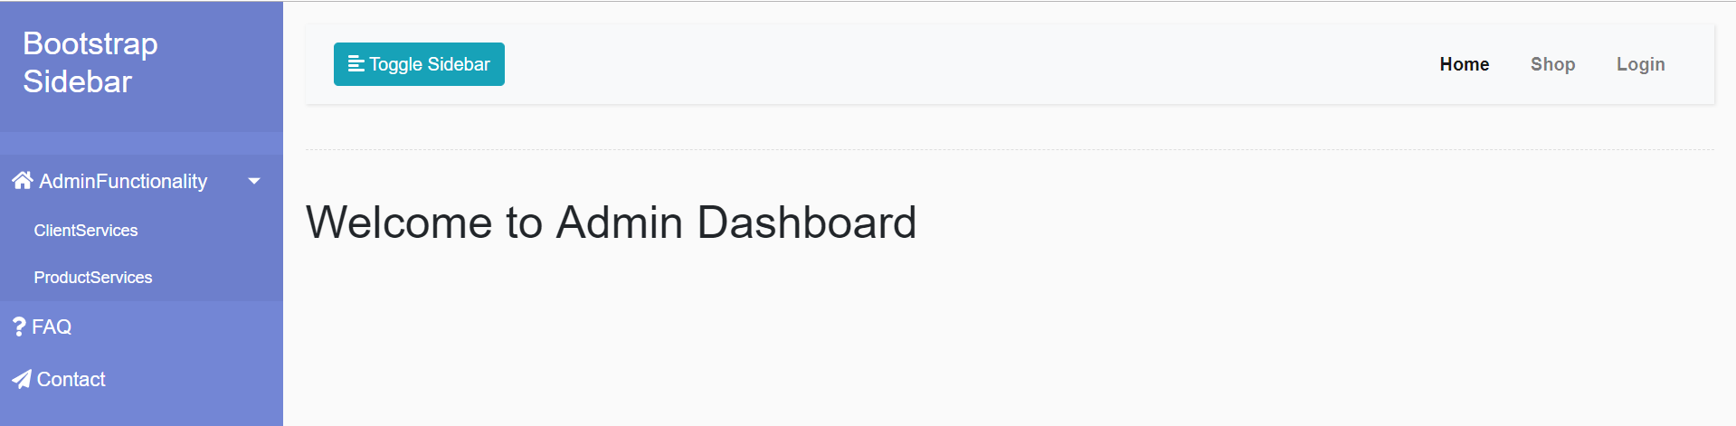

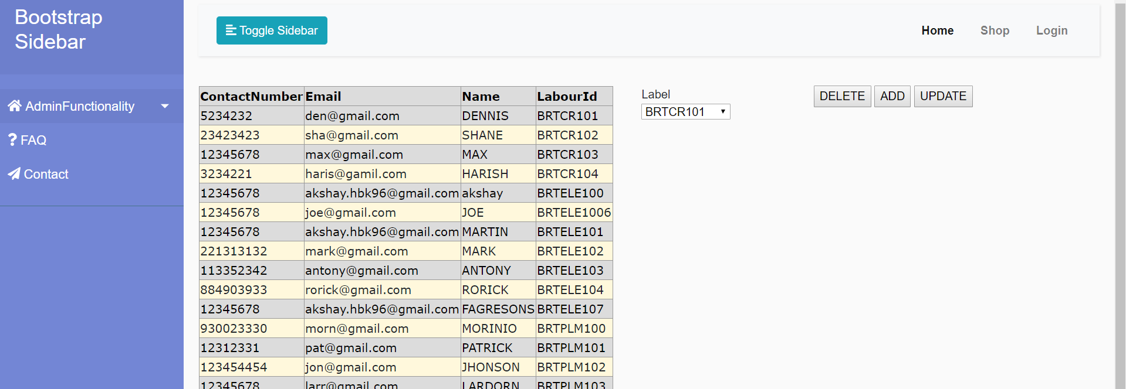

DML:

Insert into Cables values('CBL001','HPM Heavy Duty Cable ','Cables','The HPM garden cable RGL9 is a 1.3mm² standard duty cable','51','images/cable1.jpg'),

('CBL002','Narva Single Core Cable ','Cables','Handy roll of 10 Amp Single Core Cable on a 7 metre reel','51','images/cable2.jpg'),

('CBL003','Narva Single Core Cable ','Cables','Weller Crescent Cable Ties are high quality, self locking nylon cable ties ','51','images/cable3.jpg'),

('CBL004','Deta Corrugated Conduit ','Cables','Weller Crescent Cable Ties are high quality, self locking nylon cable ties','51','images/cable4.jpg'),

('CBL005','Deta Corrugated ','Cables','Deta 20mm Metal Saddles are made from zinc plating making them perfect for use indoors or out.','51','images/cable5.jpg'),

('CBL006','Deta Corrugated Conduit ','Cables','DETA 20mm Metal Saddles are made for Australian and New Zealand conditions','51','images/cable6.jpg'),

('CBL007','Vinyl Tape ','Cables','Handy pack of multi-purpose cable ties UV stabalised Black and clear colours','51','images/cable7.jpg'),

('CBL008','Crescent Cable Ties ','Cables','Handy pack of multi-purpose cable ties UV stabalised Black and clear colours','51','images/cable8.jpg'),

('CBL009','Crescent ','Cables','The HPM garden cable RGL9 is a 1.3mm² standard duty cable','51','images/cable9.jpg');

Insert into BathShower values('BS001','Foreno Tigerjet Shower ','BathShower','Replacement single function slide shower handpiece','30','images/bath1.jpg'),

('BS002','Estilo Function Shower','BathShower','Estilo 3 function Hand Shower Set comes complete with hose, adjustable wall bracket and supply elbow','50','images/bath2.jpg'),

('BS003','Felton Odyssey Shower','BathShower','Affordable, yet without compromise on quality, Odyssey is a classic ','30','images/bath3.jpg'),

('BS004','Foreno Espree Shower','BathShower','Foreno’s popular Tigerjet slide shower offers simplicity','45','images/bath4.jpg'),

('BS005','Mondella WELS 3 Star','BathShower','Add some affordable luxury to your bathroom with Mondella.','60','images/bath5.jpg'),

('BS006','Foreno Solitaire Shower','BathShower','Replacement single function slide shower handpiece','10','images/bath6.jpg'),

('BS007','Foreno Chrome I-Factor','BathShower','Replacement single function slide shower handpiece','90','images/bath7.jpg');

Insert into Batteries values('BT001','Varta AAA Batteries','Batteries','Cost effective and long lasting, this 24 value pack of alkaline AAA batteries','30','images/batteries1.jpg'),

('BT002','Alkaline Batteries','Batteries','Non-rechargeable Packaged: Blister pack, 2 per card','20','images/batteries2.jpg'),

('BT003','Super Heavy Duty','Batteries','Eveready AA Carbon Zinc Super Heavy Duty Battery Family Saver Pack - 20 batteries included.','14','images/batteries3.jpg'),

('BT004','Alkaline Battery','Batteries','Rating 1.5V. Recommended applications: Clocks, electronic toys','30','images/batteries4.jpg'),

('BT005','Batteries Rechargable','Batteries','Ready to use rechargeable D handy 2 pack batteries ensure your appliances and equipment','10','images/batteries5.jpg'),

('BT006','Varta AAA Batteries ','Batteries','Cost effective and long lasting, this 24 value pack of alkaline AAA batteries','56','images/batteries6.jpg'),

('BT007','Varta AAA Batteries ','Batteries','Cost effective and long lasting, this 24 value pack of alkaline AAA batteries','55','images/batteries7.jpg'),

Insert into Cuttingtools values('CT001','Craftright Hacksaw','Cuttingtools','Convenient, fast and adjust the tightness of blade','30','images/cutting1.jpg'),

('CT002','Hacksaw Frame','Cuttingtools','Non-rechargeable Packaged: Blister pack, 2 per card','20','images/cutting2.jpg'),

('CT003','Lightweight Hacksaw ','Cuttingtools','The IRWIN I-75 Lightweight Hacksaw has a durable full metal frame and is ideal for professional users.','14','images/cutting3.jpg'),

('CT004','Bahco 475mm','Cuttingtools','Bahco 19" Handsaw is a great universal saw for cutting though all types of wood','30','images/cutting4.jpg'),

('CT005','Stanley Hand Saw ','Cuttingtools','The Stanley 1-20-090 Handsaw 500mm/20" features 7 teeth per inch','10','images/cutting5.jpg'),

('CT006','Ryobi 1500W','Cuttingtools','The Ryobi RCS1500-G provides outstanding performance','56','images/cutting6.jpg'),

('CT007','Circular Saw','Cuttingtools','The Ozito 185mm (7 1/4") Circular Saw offers a powerful 1300W motor','55','images/cutting7.jpg');

DDL:

create table Cables(ProductId varchar(15) not null,

ProductName varchar(25) not null,

ProducType varchar(15) not null,

Description varchar(max) not null,

Price int not null,

image varchar(max) not null

constraint cables_pk primary key (ProductId));

create table Batteries(ProductId varchar(15) not null,

ProductName varchar(25) not null,

ProducType varchar(15) not null,

Description varchar(max) not null,

Price int not null,

image varchar(max) not null

constraint cBatteries_pk primary key (ProductId));

create table ScrewDrivers(ProductId varchar(15) not null,

ProductName varchar(25) not null,

ProducType varchar(15) not null,

Description varchar(max) not null,

Price int not null,

image varchar(max) not null

constraint ScrewDrivers_pk primary key (ProductId));

create table Cuttingtools(ProductId varchar(15) not null,

ProductName varchar(25) not null,

ProducType varchar(15) not null,

Description varchar(max) not null,

Price int not null,

image varchar(max) not null

constraint Cuttingtools_pk primary key (ProductId));

create table Hammers(ProductId varchar(15) not null,

ProductName varchar(25) not null,

ProducType varchar(15) not null,

Description varchar(max) not null,

Price int not null,

image varchar(max) not null

constraint Hammers_pk primary key (ProductId));

create table Pipes(ProductId varchar(15) not null,

ProductName varchar(25) not null,

ProducType varchar(15) not null,

Description varchar(max) not null,

Price int not null,

image varchar(max) not null

constraint Pipes_pk primary key (ProductId));

create table Pumps(ProductId varchar(15) not null,

ProductName varchar(25) not null,

ProducType varchar(15) not null,

Description varchar(max) not null,

Price int not null,

image varchar(max) not null

constraint Pumps_pk primary key (ProductId));

create table BathShower(ProductId varchar(15) not null,

ProductName varchar(25) not null,

ProducType varchar(15) not null,

Description varchar(max) not null,

Price int not null,

image varchar(max) not null

constraint BathShower_pk primary key (ProductId));

create table LawnMowers(ProductId varchar(15) not null,

ProductName varchar(25) not null,

ProducType varchar(15) not null,

Description varchar(max) not null,

Price int not null,

image varchar(max) not null

constraint LawnMowers_pk primary key (ProductId));

create table WateringDevices(ProductId varchar(15) not null,

ProductName varchar(25) not null,

ProducType varchar(15) not null,

Description varchar(max) not null,

Price int not null,

image varchar(max) not null

constraint WateringDevices_pk primary key (ProductId));

create table CleaningAccessories

(ProductId varchar(15) not null,

ProductName varchar(25) not null,

ProducType varchar(15) not null,

Description varchar(max) not null,

Price int not null,

image varchar(max) not null

constraint CleaningAccessories_pk primary key (ProductId));

drop table CleaningAccessories;

drop table WateringDevices;

drop table LawnMowers;

drop table BathShower;

drop table Pumps;

drop table Pipes;

drop table Hammers;

drop table Cuttingtools;

drop table ScrewDrivers;

drop table Batteries;

drop table Cables;

create table Add_Cart(ProductId varchar(15) not null,

ProductName varchar(25) not null,

ProducType varchar(15) not null,

Description varchar(max) not null,

Price int not null,

image varchar(max) not null

constraint Add_Cart_pk primary key (ProductId));